# Analysis of Amplitude Modulated and Demodulated Signal using MATLAB

**LAB # 04**



FALL 2022

**Digital Signal Processing**

Submitted By: **Hamid Ur Rehman**

Registration No: **20PWCSE1969**

Section: **C**

**“On my honor, as student of University of Engineering and**

**Technology, I have neither given nor received unauthorized**

**assistance on this academic work”**

**Department of Computer Systems Engineering**

**University of Engineering and Technology Peshawar**

**CSE 402L: Digital Signal Processing**

|  |  |  |  |  |
| --- | --- | --- | --- | --- |
| **Demonstration of Concepts** | **Poor (Does not meet expectation (1))**  The student failed to demonstrate a clear understanding of the assignment concepts | **Fair (Meet Expectation (2-3))**    The student demonstrated a clear understanding of some of the assignment concepts | **Good (Exceeds Expectation (4-5)**    The student demonstrated a clear understanding of the assignment concepts | **Score**  **30%** |
| **Accuracy** | The student completed ( <50%) tasks and provided MATLAB code and/or Simulink models with errors. Outputs shown are not correct in form of graphs (no labels) and/or tables along with incorrect analysis or remarks. | The student completed partial tasks (50% - <90%) with accurate MATLAB code and/or Simulink models. Correct outputs are shown in form of graphs (without labels) and/or tables along with correct analysis or remarks. | The student completed all required tasks (90%-100%) with accurate MATLAB code and/or Simulink models. Correct outputs are shown in form of labeled graphs and/or tables along with correct analysis or remarks. | **30%** |
| **Following Directions** | The student clearly failed to follow the verbal and written instructions to successfully complete the lab | The student failed to follow the some of the verbal and written instructions to successfully complete all requirements of the lab | The student followed the verbal and written instructions to successfully complete requirements of the lab | **20%** |
| **Time Utilization** | The student failed to complete even part of the lab in the allotted amount of time | The student failed to complete the entire lab in the allotted amount of time | The student completed the lab in its entirety in the allotted amount of time | **20%** |

**Tasks:**

**5. Input Modulation Index from 0 to 1.4, the increment step should be 0.2.**

**Observe/analyze and comment about the output observed.**

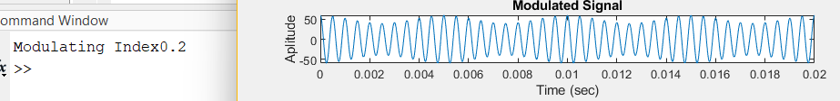

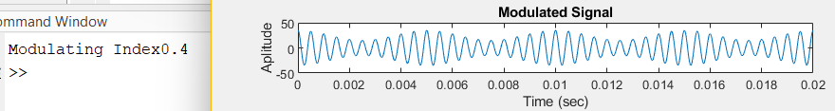

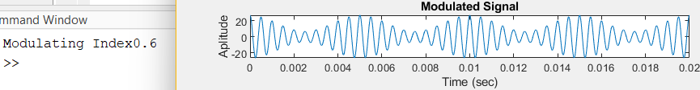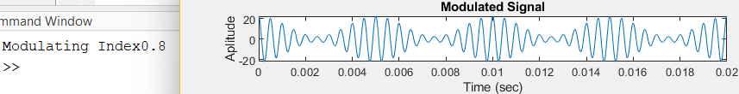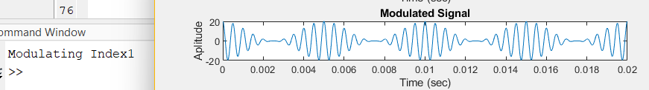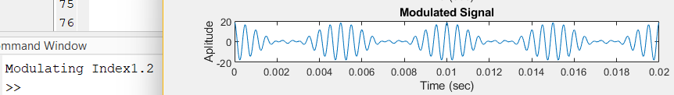

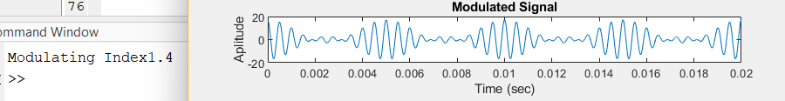

We can see that by changing the modulating index, it is changing the envelope of modulating signal as shown above or it is distorting the signal.

1. **Define Amplitude Modulation:**

A process by which the wave signal is transmitted by modulating the amplitude of the signal is called amplitude modulation. It is often called AM and is mostly used in the form of electronic communication.

1. Define Amplitude Demodulation:

Demodulation is the process of recovering the original data-carrying signal from a carrier wave. A demodulator is an electronic circuit that recovers the information content from a modulated carrier wave.

1. **List three reasons, why we implement Amplitude Modulation in Communication Systems:**
   1. Reduction in the height of antenna
   2. Avoids mixing of signals
   3. Increases the range of communication
2. **Define Modulation Index:**

The modulation index is the ratio of the frequency deviation of the modulated signal to the message signal bandwidth.

**Procedure:**

1. Create and plot (both time and frequency domain) a message signal with amplitude 10 and frequency 200 Hz.

2. Create and plot (both time and frequency domain) a Carrier signal with amplitude 10/Modulation Index and frequency 2000 Hz.

3. Modulate the message signal with the carrier using the desired Modulation Index. Plot modulated signal in both time and frequency domain. Observe/Analyze the output.

Hint: y = ammod (ym, fc, 100000, 0, Ac);

4. Demodulate the Modulated signal. Observe/Analyze the output.

Hint: z = amdemod (y, fc, 100000, 0, Ac);

1. Following are the plots of the desired outputs.

**Code:**

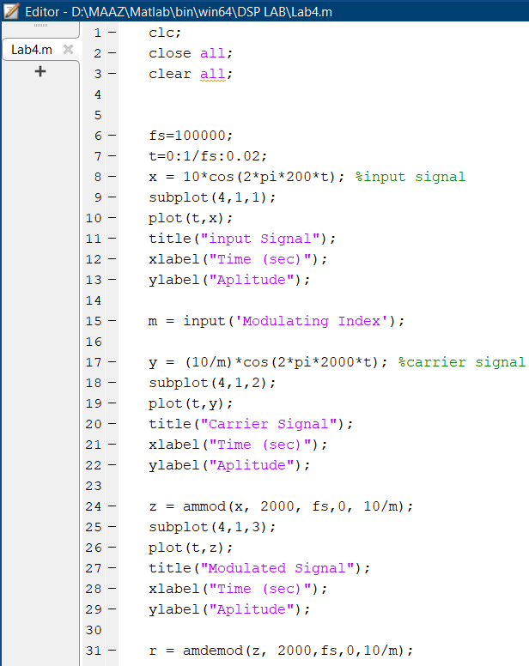

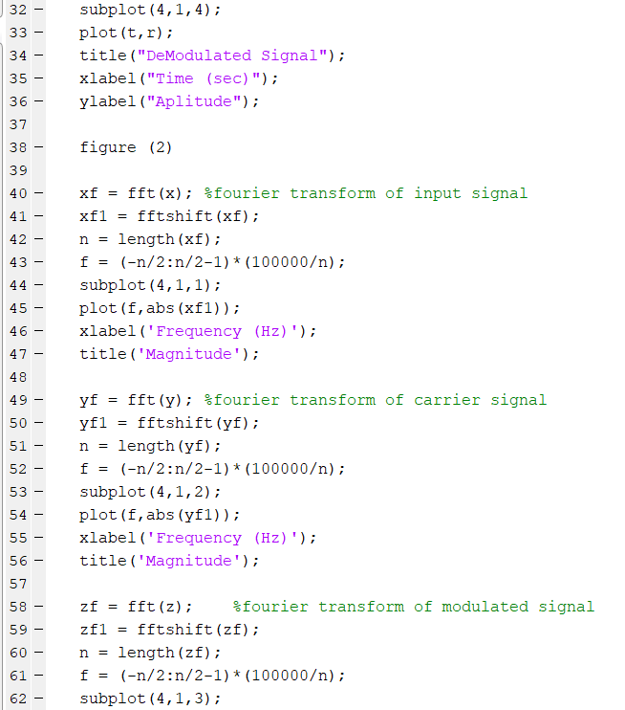

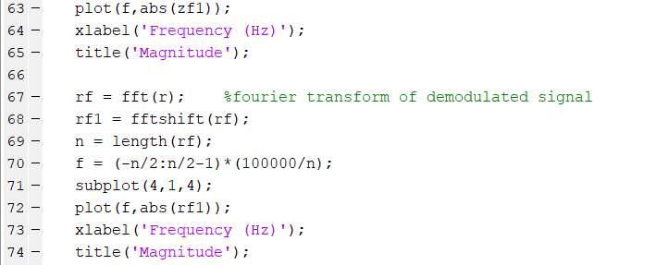

**Output:**

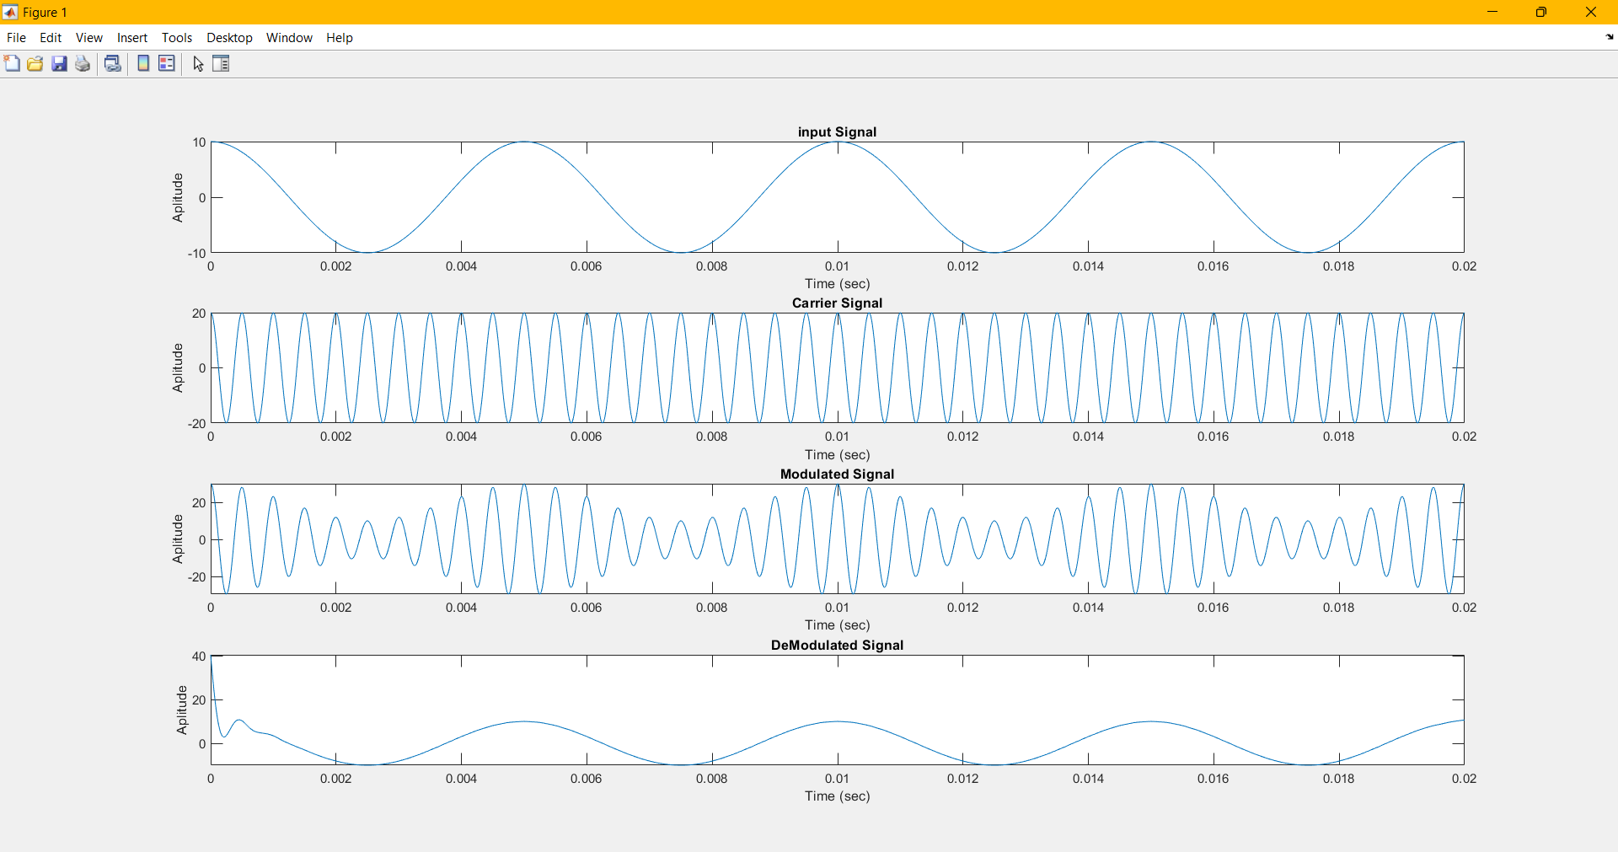

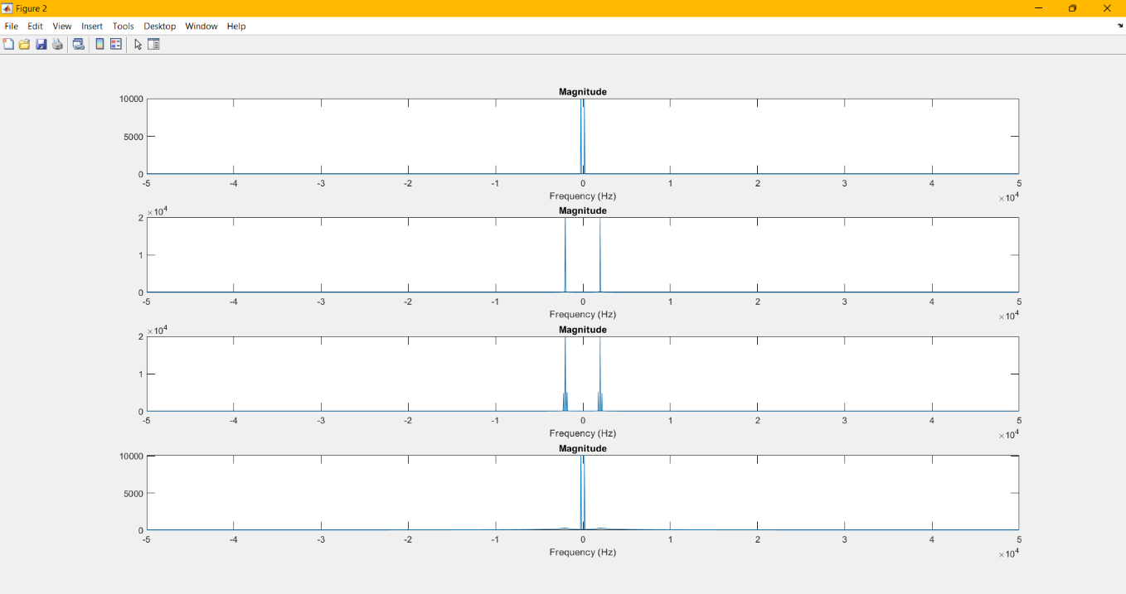

**Remarks:**

In this lab we create an input and carrier signal (in time and frequency domain). Then we do amplitude modulation of both. Finally, we transmit our signal. At the receiver end when we receive our signal, we demodulate that signal and get our msg or information signal again. When we are changing the value of modulating index, the change will occur in modulated signal. When the value of modulating index > 1, the greater the distortion in the modulated signal.